**Children are THREE times more likely to smoke before they become 11 if they don't live with both parents**

* **One in four children experience parental absence before they turn seven**
* **It makes them more likely to try alcohol before they reach the age of 11**
* **Youngsters are more likely to develop alcohol and nicotine addictions**
* **Scientists warn this could increase the risk of cancers and heart disease**

By [Stephen Matthews For Mailonline](http://www.dailymail.co.uk/home/search.html?s=&authornamef=Stephen+Matthews+For+Mailonline)

**PUBLISHED:** 23:30, 10 October 2016 | **UPDATED:** 23:30, 10 October 2016

* [e-mail](mailto:?subject=Read%20this:%20Children%20are%20THREE%20times%20more%20likely%20to%20smoke%20before%20they%20become%2011%20if%20they%20don%27t%20live%20with%20both%20parents&body=Children%20are%20THREE%20times%20more%20likely%20to%20smoke%20before%20they%20become%2011%20if%20they%20don%27t%20live%20with%20both%20parents%0A%0ASimilarly%2C%20children%20who%20experienced%20parental%20absence%20were%2046%20per%20cent%20more%20likely%20to%20have%20started%20drinking%20alcohol%20by%20the%20age%20of%2011%2C%20researchers%20from%20University%20College%20London%20found.%0A%0Ahttp%3A%2F%2Fwww.dailymail.co.uk%2Fhealth%2Farticle-3830987%2FChildren-THREE-times-likely-smoke-11-don-t-live-parents.html%3Fito%3Demail_share_article-top%0A%0A%0AMost%20Read%20Articles%3A%0A%0ADr%20Pimple%20Popper%20bursts%20a%20huge%20cyst%20from%20the%20corner%20of%20a%20man%27s%20eye%20in%20possibly%20her%20most%20repulsive%20video%20yet%0Ahttp%3A%2F%2Fwww.dailymail.co.uk%2Fhealth%2Farticle-4028510%2FDr-Pimple-Popper-bursts-huge-cyst-corner-man-s-eye-possibly-repulsive-video-yet.html%3Fito%3Demail_share_article-top_most-read-articles%0A%0ATeenager%20whose%20painful%20skin%20condition%20left%20her%20covered%20in%20SCALES%2C%20bleeding%20and%20in%20agony%20is%20cured%20by%20a%20cancer%20drug%0Ahttp%3A%2F%2Fwww.dailymail.co.uk%2Fhealth%2Farticle-4028006%2FTeenager-painful-skin-condition-left-covered-SCALES-bleeding-agony-cured-cancer-drug.html%3Fito%3Demail_share_article-top_most-read-articles%0A%0ATom%2C%20who%20was%20so%20full%20of%20life%2C%20was%20killed%20in%20a%20tragic%20hockey%20accident%20at%20the%20age%20of%2022%3A%20Now%20his%20organs%20have%20helped%20up%20to%2050%20people%20in%20need%20of%20transplants%0Ahttp%3A%2F%2Fwww.dailymail.co.uk%2Fhealth%2Farticle-4026676%2FTom-life-killed-tragic-hockey-accident-age-22-organs-helped-FIFTY-people-need-transplant.html%3Fito%3Demail_share_article-top_most-read-articles%0A%0A)

**34**shares

**[2](http://www.dailymail.co.uk/health/article-3830987/Children-THREE-times-likely-smoke-11-don-t-live-parents.html" \l "comments)**

[View comments](http://www.dailymail.co.uk/health/article-3830987/Children-THREE-times-likely-smoke-11-don-t-live-parents.html" \l "comments)

Going through a divorce is not only stressful on you - it has a lasting impact on your children.

Often growing up emotionally scarred, children are susceptible to trying new things as a result of their changing home environment.

But new research suggests youngsters who don't live with both parents while growing up are more likely to smoke or drink before they become a teenager.

The effects of parental absence could increase the risk of lung cancer and cardiovascular disease, scientists warn.

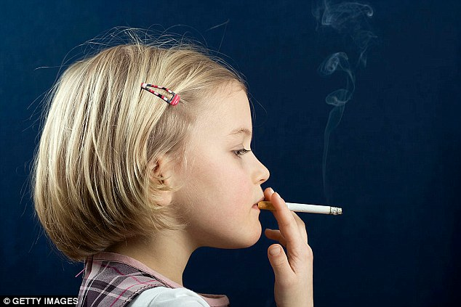

+2

Children who don't live with both parents while growing up are more likely to smoke or drink before they become a teenager, new research suggests

While children are more likely to develop addictions to both alcohol and nicotine if they consume the drugs growing up.

Researchers from University College London examined data from nearly 11,000 children born between September 2000 and January 2002.

Both children and their families were surveyed when they turned nine months, three, five, seven and 11 years old.

**RELATED ARTICLES**

* [Previous](http://www.dailymail.co.uk/health/article-3830987/Children-THREE-times-likely-smoke-11-don-t-live-parents.html)
* [1](http://www.dailymail.co.uk/health/article-3830987/Children-THREE-times-likely-smoke-11-don-t-live-parents.html)
* [Next](http://www.dailymail.co.uk/health/article-3830987/Children-THREE-times-likely-smoke-11-don-t-live-parents.html)
* [**[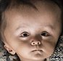](http://www.dailymail.co.uk/health/article-3830822/Family-baby-head-swelled-twice-normal-size-sold-desperate-bid-treatment.html)Family of baby whose head has swelled to twice its normal...**](http://www.dailymail.co.uk/health/article-3830822/Family-baby-head-swelled-twice-normal-size-sold-desperate-bid-treatment.html)[**[](http://www.dailymail.co.uk/health/article-3830867/Why-NOT-wash-hands-soap-GOOD-thing-health-allergy-expert-explains.html)Why you should NOT wash your hands: Less soap could be a...**](http://www.dailymail.co.uk/health/article-3830867/Why-NOT-wash-hands-soap-GOOD-thing-health-allergy-expert-explains.html)[**[](http://www.dailymail.co.uk/health/article-3830776/NHS-offers-men-33-hour-intimate-examinations-trainee-doctors-warns-body-confident-need-apply.html)NHS paying £33-an-hour for volunteers willing to have their...**](http://www.dailymail.co.uk/health/article-3830776/NHS-offers-men-33-hour-intimate-examinations-trainee-doctors-warns-body-confident-need-apply.html)[**[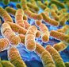](http://www.dailymail.co.uk/health/article-3830628/Ever-food-poisoning-risk-Crohn-s-disease.html)Ever had food poisoning? Why YOU could be more at risk of...**](http://www.dailymail.co.uk/health/article-3830628/Ever-food-poisoning-risk-Crohn-s-disease.html)

**SHARE THIS ARTICLE**

Share

**34** shares

They found one in four children had experienced parental absence - such as a death or a separation - by the time they were seven.

Those who were only living with one parent were nearly three times more likely to smoke before becoming a teenager.

Similarly, children who experienced absence were 46 per cent more likely to have started drinking alcohol by the age of 11.



+2

Similarly, children who experienced parental absence were 46 per cent more likely to have started drinking alcohol by the age of 11

Having an absent parent has previously been linked to an increased likelihood of children smoking and drinking in adolescence.

However, this study was the first to link parental absence to these activities in younger children.

Experts believe it could to do with a lack of parental supervision and the adoption of unhealthy coping mechanisms.

There has been suggestion of an increased risk of diseases, such as lung cancer and cardiovascular disease, when people start smoking at an earlier age, they cautioned.

And youngsters are more likely to develop alcohol and nicotine dependence if they consume these substances from an early age.

The authors said: 'Our findings suggest that parental absence is associated with increased risk of smoking and alcohol consumption prior to adolescence.

'Consequently early life might be an important time to intervene in order to prevent the uptake of risky health behaviours.'

The study was published in the Archives of Disease in Childhood.

Read more: <http://www.dailymail.co.uk/health/article-3830987/Children-THREE-times-likely-smoke-11-don-t-live-parents.html#ixzz4SoAMFdEM>   
Follow us: [@MailOnline on Twitter](http://ec.tynt.com/b/rw?id=bBOTTqvd0r3Pooab7jrHcU&u=MailOnline) | [DailyMail on Facebook](http://ec.tynt.com/b/rf?id=bBOTTqvd0r3Pooab7jrHcU&u=DailyMail)